Web and Android Based Industrial Wastewater Monitoring System Using Internet of Things and JavaScript Object Notation Web Token

Amin Suharjono  Department of Electrical Engineering  Politeknik Negeri Semarang  Semarang, Indonesia  amin.suharjono@polines.ac.id | Imam Zaenal Abidin  Department of Electrical Engineering  Politeknik Negeri Semarang  Semarang, Indonesia  imam.43121115@mhs.polines.ac.id | Muhammad Adriano Khairur  Rizky Setyawan  Department of Electrical Engineering  Politeknik Negeri Semarang  Semarang, Indonesia  adrian.43121118@mhs.polines.ac.id | Roni Apriantoro  Department of Electrical Engineering  Politeknik Negeri Semarang  Semarang, Indonesia  roni.apriantoro@polines.ac.id

Abstract — The increasing demand for industrial wastewater monitoring systems is a strategic challenge in ensuring compliance with environmental regulations and preventing pollution. Most existing systems are unable to integrate multi-protocol communication, layered security mechanisms, and responsive notification features. This research designs and implements an Internet of Things (IoT)-based wastewater monitoring system with JSON Web Token (JWT), supporting HyperText Transfer Protocol (HTTP) and Message Queueing Telemetry Transport (MQTT) protocols, equipped with AES-128 encryption, HTTP Secure (HTTPS), and web-based and Android interfaces. The methodology used is Agile-Scrum, covering the planning, design, implementation, and testing stages, including black box, security, notification, performance, and User Acceptance Testing (UAT). The results of the study show that the system is capable of monitoring parameters such as discharge, turbidity, pH, ammonia nitrogen, and Chemical Oxygen Demand (COD) in real-time, with a 100% success rate in 16 black box testing scenarios. Performance testing recorded DOMContentLoaded time <250 ms, Android CPU usage <10%, and memory consumption of 20–31 MB. The AES-128 key entropy is equivalent to a theoretical resistance of ±10²¹ years against brute force attacks. Internal notifications and WhatsApp proved effective in providing alerts when parameters exceeded thresholds. UAT showed an acceptance rate of 93.25%, indicating that the system met expectations in terms of interface and user experience. The system is recommended for industries with liquid waste and can be integrated with machine learning in future research for waste quality prediction.
Keywords — IoT, Industrial wastewater, Web application, Android application.

Introduction
Monitoring is the process of systematically and continuously collecting data to monitor a specific condition or parameter. In the context of environmental management, monitoring systems serve to ensure compliance with regulations, detect anomalies, and provide accurate data for decision-making [1]. One important application is the monitoring of industrial wastewater, which is regulated in Ministry of Environment and Forestry Regulation Number P.80/MENLHK/SETJEN/KUM.1/10/2019 concerning the monitoring of wastewater quality through the Continuous and Networked Wastewater Quality Monitoring System (SPARING) [2]. This system monitors key parameters such as pH, COD, TSS, NH₃-N, and discharge in real-time to ensure compliance with wastewater quality standards [3].
Technological developments in the era of the Fourth Industrial Revolution have brought about the IoT as a solution for more effective and automated monitoring. IoT enables sensor devices to communicate with each other via the internet, allowing data collection to be carried out in real time [4]. However, existing IoT monitoring systems still have a number of limitations, such as the dominance of passive monitoring without notification when parameters exceed thresholds [5], limited access only through websites, and low interoperability due to differences in communication protocols between devices [6]. In addition, the increasing number of connected devices actually increases the risk of data security and cyber attacks on the IoT ecosystem [7].
Interoperability and security issues are major challenges in the development of IoT systems. To overcome this, a reliable authentication and authorization mechanism is needed, one of which is through the implementation of JavaScript Object Notation Web Token (JWT) [8]. JWT enables efficient verification of device and user identities, maintains data integrity, and supports system scalability [9].

Literature Review
In preparing this study, the author reviewed various previous studies related to IoT-based monitoring systems and the problems associated with them. One of the main issues that is often raised is the security of IoT communication protocols. Shakdher et al. in their study entitled "Security Vulnerabilities in Consumer IoT Applications" found that some IoT devices still send data in plaintext format, making them vulnerable to Man In The Middle (MITM) attacks. Using the Wireshark application to analyze data traffic, the researchers emphasized the importance of adding security features such as hashing to protect data from cyber attacks [7].
In response to the same issue, Shodiq et al., through their research entitled "Secure MQTT Authentication and Message Exchange Methods for IoT Constrained Devices," proposed a JWT-based authentication mechanism for the MQTT protocol. The aim was to prevent illegal access to the network while improving data security using XXTEA encryption. Test results show that this mechanism is effective against brute force and MITM attacks, while remaining compatible with low-power devices [10]. Quantitatively, the implementation of the JWT mechanism with a secret length of approximately 64 bits of entropy provides a key space of 2(64)possible combinations. Assuming a brute force attack rate of 10(6) guesses per second, it would take approximately 10(10) years to guess correctly. This value shows that the level of security obtained depends not only on the key length, but also on the random distribution of its constituent characters [11].
Research in the field of water quality monitoring has also been extensively conducted. Bogdan et al. in their study "Low-Cost Internet-of-Things Water-Quality Monitoring System for Rural Areas" developed an Arduino UNO-based system with sensors to measure temperature, pH, Total Dissolved Solids (TDS), and turbidity. Data is transmitted via Bluetooth connectivity to an Android application for real-time monitoring. Although useful, this system has communication distance limitations [12]. Raman & Martin, through their study "IoT-Enabled Water Pollution Detection for Real-Time Monitoring and Pollution Source Identification with MQTT Protocol," also built an MQTT protocol-based IoT platform that can transmit sensor data in real-time, such as chemical composition, pH, Dissolved Oxygen (DO), and NH3-N. This system facilitates rapid identification of pollution sources so that preventive measures can be taken more effectively [13].
On the other hand, research related to liquid waste monitoring is also developing rapidly. Febriana & Farros, in their study entitled "Design of a Multipurpose Industrial Internet of Things Board for Liquid Waste Monitoring," designed a multipurpose IoT board with LoRa connectivity to monitor pH, COD, TSS, NH3-N, and water discharge. The data is stored on an SD card and displayed on a Nextion Display, and can be monitored via ThingSpeak. However, this system does not yet have a mobile-based monitoring platform and notification service to notify users of significant changes in sensor values [7]. Salem et al. in their study "An Industrial Cloud-Based IoT System for Real-Time Monitoring and Controlling of Wastewater" also used ESP8266 to monitor the pH and temperature of liquid waste, with data sent to the ThingSpeak platform and equipped with SMS notifications. However, this method has not implemented hashing-based data security [14].
Based on these studies, it appears that most existing systems are similar to this study, but still have weaknesses such as limited communication protocol support, lack of data security systems, and absence of notification features. This research offers several advantages, including the application of a message broker for MQTT protocol integration, the use of HTTPS encryption, and JWT hashing to maintain data security and integrity. In addition, the system is equipped with notifications via browser and WhatsApp so that users can immediately detect any anomalies in sensor values. A summary of the literature review can be seen in Table I.
- Literature Review Summary
Reference | Interface | Protocol | Notification | Security
(Febriana & Farros, 2024) | Website | HTTP | - | -
(Raman & Martin, 2024) | Website | MQTT | - | -
(Salem et al. 2022) | Website | HTTP | SMS | -
(Bogdan et al. 2023) | Android | HTTP | Built-In | -
(Shakdher et al. 2019) | Website | HTTP | - | -
(Shodiq et al. 2021) | Website | MQTT | - | JWT, XXTEA Encryption
Research Proposal | Website, Android | HTTP, MQTT | Browser (Built-In), WhatsApp | JWT, AES Encryption, HTTPS

Research Methodology
The research method used in this study is Agile-Scrum, an iterative software development method that allows requirements and solutions to evolve through team collaboration. Scrum organizes the development process into sprint cycles, where each sprint includes planning, analysis, design, implementation, testing, and review [15].
The process begins with planning in the form of literature studies and identification of hardware and software requirements, followed by system architecture design, use case diagrams, ERDs, flowcharts, and user interface designs for web and Android applications. The implementation stage involves building APIs using Node.js and Next.js-based application displays, while data is stored in a MySQL database. After the system was developed, a series of tests were conducted, including black box testing, JWT security testing, notifications, performance, and User Acceptance Testing (UAT). The results of these tests formed the basis for evaluation and debugging before the system was released through the Misred-IoT server and WebView-based Android application.

System Architecture
The system architecture developed in this study consists of two ESP32 microcontroller-based IoT nodes equipped with pH, COD, turbidity, NH₃-N, and water flow sensors to measure liquid waste parameters. The first node communicates with the server using the HTTP protocol, while the second node uses the MQTT protocol, both equipped with security mechanisms through JSON Web Token (JWT) hashing. The sensor data sent is validated by the server, stored in a MySQL database, and displayed in real-time through a web-based monitoring platform and Android. The web application is built with the Next.js framework, while the Android application uses WebView to display an interface connected to the server, allowing users to monitor and authenticate securely and in an integrated manner. The system architecture can be seen in Figure 1.
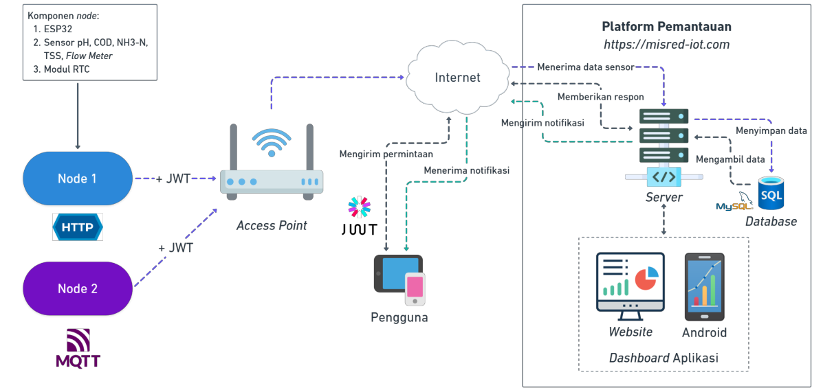
- Overall System Architecture

Use Case Diagram
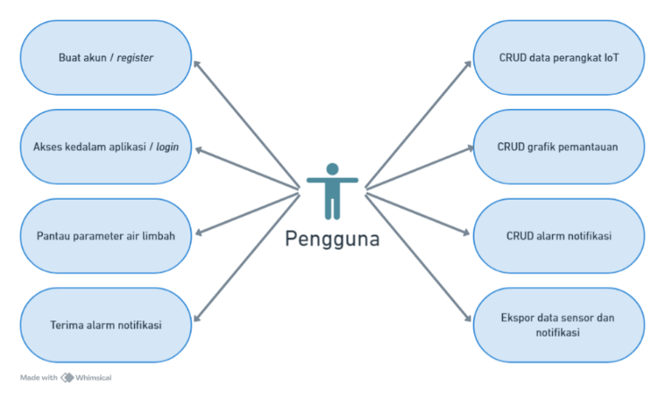
- Use Case Diagram
Based on Figure 2, the system use case describes the main interactions between users and the IoT-based liquid waste monitoring platform. The main actors include administrators and users, who have different access rights in managing devices, data streams, and notifications. The admin is responsible for adding, changing, and deleting devices as well as verifying sensor data, while users focus on monitoring environmental parameters in real-time via a web or Android interface. This use case ensures that the system is able to support monitoring needs with secure authentication based on JWT.

Entity Relationship Diagram (ERD)
ERD is designed to illustrate the relationships between entities in the monitoring system. The main entities include users, devices, data streams, and alarms, which are interconnected through identification and sensor data management relationships. This MySQL-based database schema supports structured storage for liquid waste sensor parameters, user authentication, and notification settings. The ERD is the foundation for database design so that data integrity and consistency can be guaranteed. The ERD can be seen in Figure 3.
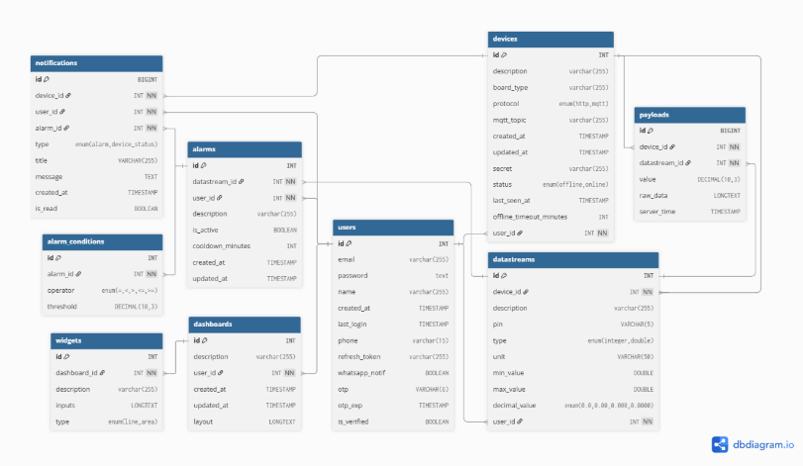
- Entity Relationship Diagram

Flow Chart
The system flow chart explains the process flow starting from the transmission of sensor data by the ESP32 node, JWT token validation on the server, data storage in the MySQL database, to data visualization on the web and Android applications. The flow diagram also illustrates the user authentication and authorization process, the IoT device process, and the application interface usage process.
The user authentication and authorization process flow can be seen in Figure 4, the IoT device process flow can be seen in Figure 5, and the application interface usage process flow can be seen in Figure 6.
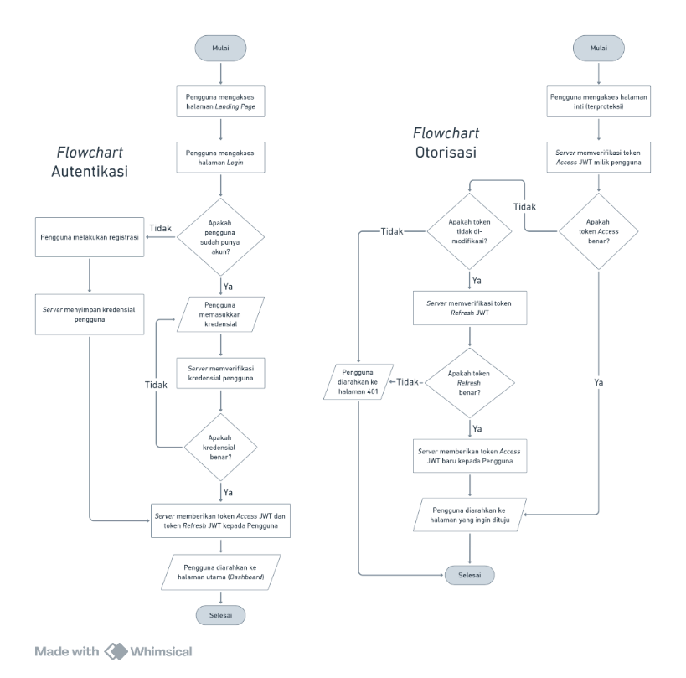
- Authentication and User Authorization Flow Chart
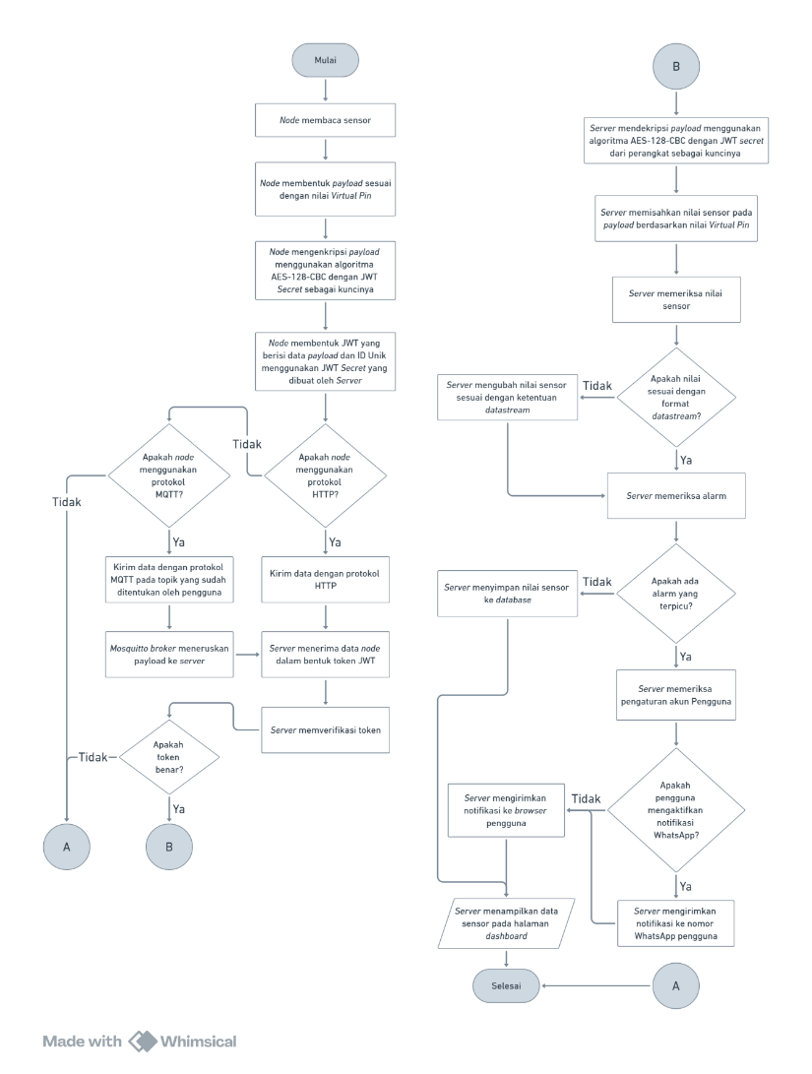
- IoT Device Flow Chart

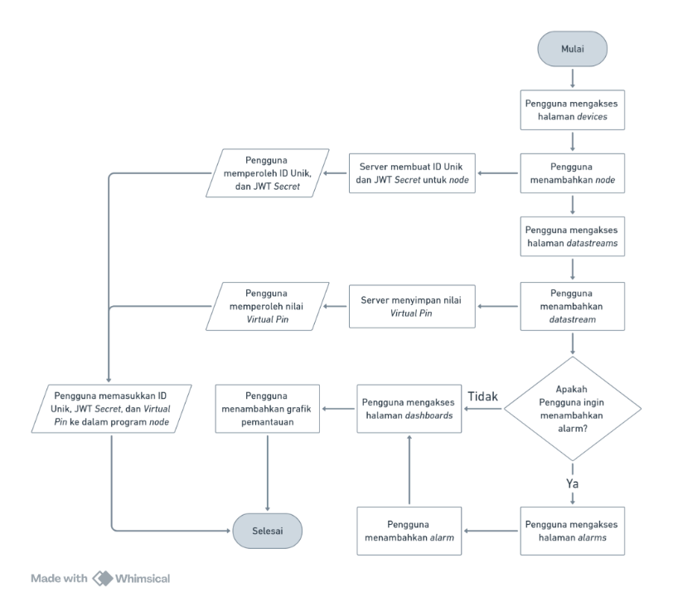
- Application Interface Usage Flow Chart

Results and Analysis
The testing focused on functionality, performance, security, and user acceptance to ensure that the system runs in accordance with the research objectives. Each test result was analyzed systematically to evaluate the system's suitability for the identified needs and to assess the system's contribution to improving the effectiveness of real-time industrial wastewater monitoring.

Black Box Testing Results
The results of black box testing are whether the application runs successfully or fails according to the scenario. This test only focuses on the functionality and output of the application. The functionality test results can be seen in Figure 7.

- Black Box Testing Results
B Based on the results of black box testing of the system, 16 test scenarios were carried out covering all the main features of the application, including the login process, IoT device management, data stream management, monitoring graph visualization, and notification alarm settings. The test results are presented in the form of a pie chart that illustrates the distribution of test statuses for each function. From the overall testing, all scenarios showed a "Compliant" status (100%), which means that all functions ran according to the expected parameters. These results indicate that in terms of functionality, the system has met the basic user requirements as designed in the system design stage. Each input provided produced the appropriate output, and no errors were found in the process flow or user interface display during testing.

Security Testing Results
Security testing was conducted to assess the resilience of the JWT-based authentication mechanism used by the system. The testing focused on evaluating the theoretical entropy of the secret key and simulating its resilience against brute force attacks. The analysis was conducted based on standard cryptography approaches and computational estimates.
In the developed system, the secret key for JWT is automatically generated by the server in the form of a 32-character hexadecimal random string. An example of the secret key tested is as follows:
4b3d6e7c94148b64022cece554fe79a1
The technical characteristics of the secret can be described as follows:
  - Length (L) = 32 characters
  - Character set = hexadecimal (0–9, a–f)
  - Number of unique characters (N) = 16
The entropy level of the secret is calculated using the Shannon entropy formula as presented in the following equation [16]:
$H=L⋅\log_{2}{(N)}$ (1)
$H=32⋅\log_{2}{(16})=32⋅4=128 bit$
This entropy value of 128 bits meets the minimum recommendation for secure cryptographic key strength, as proposed by the National Institute of Standards and Technology (NIST) [17], and complies with industry standards for authentication and data communication systems [18]. Based on these calculations, it can be concluded that the secret key has a high level of randomness and is not vulnerable to statistical or predictive approaches. In addition to entropy measurement, a simulation was also conducted on the secret's resistance to brute force attacks, namely a scenario in which an attacker attempts to enumerate to guess the secret value, assuming they have access to the JWT token. The number of possible secret combinations is calculated using the formula in the following equation [11]:
$C=N^{L}$ (2)
$$C=N^{L}={16}^{32}=2^{128}≈3.4×{10 }^{38} Probability$$
Assuming that the attacker uses hardware capable of making one billion or 10⁹ guesses per second (R), the estimated time to reach all possible combinations of secrets can be calculated using the following equation [18]:
$T=\frac{C}{R}$ (3)
$T=\frac{2^{128}}{{10}^{9}}​≈{10}^{29} seconds≈{10}^{21} years$
Test results show that a 32-character hexadecimal JWT secret has an entropy of 128 bits, in accordance with the minimum industry standard recommendation. A brute force attack estimate assuming 10⁹ guesses per second results in a time of more than 10²¹ years, making it practically impossible with modern computing devices. This confirms that the system has a solid security mechanism against key guessing attacks.

Notification Testing Results
Notification testing was conducted to ensure that the system is capable of providing real-time alerts when sensor parameter values exceed predetermined thresholds. The notification mechanisms tested include two channels: internal notifications via the website (bell icon in the upper right corner of the page) and external notifications via the WhatsApp application.
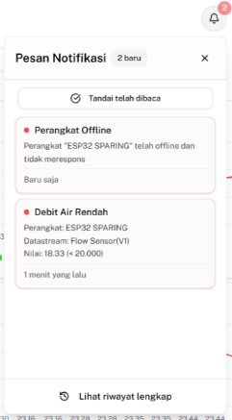
- Browser Notification Message Results
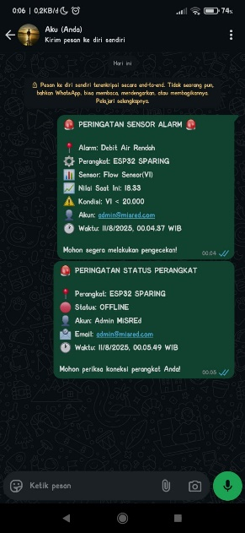
- WhatsApp Notification Message Results
Users will receive notifications if a parameter value exceeds or falls below the threshold previously set through the Alarms page. These notifications can be delivered through two media, namely through the browser display and through the WhatsApp application. On the browser display, notifications will appear in the upper right corner of the page in the form of a bell icon. Meanwhile, notifications via WhatsApp will only be sent if the user has added a phone number linked to their WhatsApp account in the account profile settings and activated the notification feature.

Performance Testing Results
Performance testing was conducted to assess the system's ability to respond quickly and efficiently to user requests. This testing focused on two platforms, namely the website and Android, by observing key metrics such as page load time (DOMContentLoaded), total finish time, CPU usage, and memory consumption.

- Website Performance Test Results
Figure 10 shows a comparison diagram indicating that the DOMContentLoaded time across all pages is relatively fast (<250 ms), which means that the HTML structure can be loaded properly by the browser and falls into the "Very good" category. However, the Finish time on several main pages such as Dashboards, Devices, and Datastreams is quite high (>3000 ms) and falls into the "Fair" category [19]. This indicates the presence of dynamic processes such as API calls, JavaScript processing, and graphical or tabular data visualization [20].
Testing on Android devices was conducted using Android Studio software, specifically through the Android Profiler feature using the View Live Telemetry task. However, the results obtained from Android Profiler are limited because the Android application was developed using the Trusted Web Activity (TWA) approach, which essentially only wraps websites on the https://misred-iot.com domain. As a result, all request activities take place within the WebView environment, so Android Profiler can only record and display information related to CPU activity, threads, and memory usage.
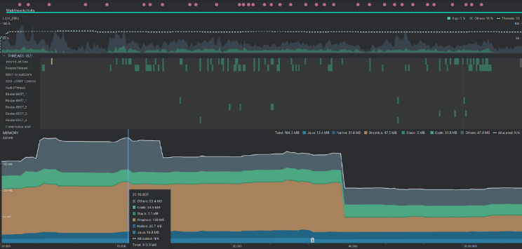
- Android Profiler Test Results
Test results using View Live Telemetry on Android Profiler show that the performance of the application in TWA mode is efficient and stable. Average CPU usage was below 10%, thread activity recorded 82 active threads including RenderThread, Binder, GCM, and WebView, while memory consumption decreased significantly from ±164 MB to ±120 MB at the 45th second, which was suspected to be due to the garbage collection process. Overall, the application runs smoothly without any significant process spikes. However, since all activities take place within WebView, the profiler can only display CPU, thread, and memory data, without recording network traffic or internal website activity, so end-to-end analysis is not fully achieved.
- User Acceptance Testing (UAT)
UAT was conducted to assess the level of user acceptance and satisfaction with the interface and functionality of the web-based system. Testing was carried out by distributing a questionnaire containing 34 statements covering UI/UX aspects such as appearance, navigation, information, performance, responsiveness, convenience, and feature functionality. Respondents provided assessments using a 4-point Likert scale [21], and the results were analyzed by calculating the average value for each statement and converting it into a percentage according to the equation used [22].

- Average Results for Each Statement
Based on the recapitulation of the average scores in Fig. 17, it was found that most statements received scores above 3, indicating that the majority of users agreed to strongly agreed with the quality of the interface and functionality of the system. The highest scores were obtained for statement number 2, "The use of colors in the graphics (such as red and green) is clear enough to distinguish the sensor devices," in the Visualization and Interface aspect; number 11, "The data filter feature works well and is easy to use," in the Functionality and Interaction aspect; and number 34 "The system provides notification information that is easy to understand," in the Notification and System Response aspect. These three statements had an average score of 3.81, equivalent to 95.25%, and were categorized as "Strongly Agree.".
Meanwhile, the statement with the lowest score is statement number 12, namely "The system provides feedback when an error occurs," which is also included in the Functionality and Interaction aspect. This statement received an average score of 3.63, equivalent to 90.75%, which remains in the "Agree" category. When calculated as a whole, the average score for all statements is 3.73, equivalent to 93.25%. These results indicate that the system has been generally well received by users in terms of comfort, ease of use, and satisfaction with the system's features and interface. Thus, it can be concluded that the developed system has successfully met user expectations and is suitable for use in an operational context [23].

Conclusion
Based on the results of design, implementation, and testing, the website and Android-based industrial wastewater monitoring system that was developed is capable of monitoring flow rate, turbidity, pH, NH₃-N, and COD parameters in real time with the support of a dashboard, device management, and an alarm system that facilitates user access. In terms of performance, the application shows adequate results with a website load time of <250 ms at the DOMContentLoaded stage, Android CPU usage below 10%, and memory of around 120 MB, making it lightweight to use. The system also successfully integrates HTTP and MQTT protocols to improve interoperability and implements layered security with JWT, AES-128, and HTTPS, accompanied by 128-bit entropy that is highly resistant to brute force attacks. Real-time notification features, both built-in and via WhatsApp, strengthen the response to critical conditions. UAT test results recorded a user acceptance rate of 93.25%, confirming that the system has met expectations in terms of interface, functionality, performance, and overall user experience.

References

[1] Gonzalez, L., Perez, M., & Romero, E. (2021). Effectiveness of real-time alert systems in IoT monitoring: A review. Sensors, 21(15), 5189. https://doi.org/10.3390/s21155189.
[2] Nurbaya, S. (2019). Peraturan Menteri Lingkungan Hidup dan Kehutanan. Kementerian Lingkungan Hidup dan Kehutanan. https://ppkl.menlhk.go.id/website/filebox/885/200306144608%20Permen%20LHK%20tentang%20SPARING.pdf.
[3] Febriana, A., & Farros, R. A. (2024). Rancang bangun industrial internet of things (IIoT) board multiguna untuk monitoring limbah cair. Tugas Akhir, Politeknik Negeri Semarang, 1-91.
[4] Sawitri, D. (2023). Internet of Things memasuki era society 5.0. KITEKTRO: Jurnal Komputer, Informasi Teknologi, dan Elektro, 8(1), 31-35.
[5] Akasiadis, C., Tryferidis, A., & Tzovaras, D. (2019). Internet of Things architecture for combined applications. IEEE Internet of Things Journal, 6(2), 2055-2070. https://doi.org/10.1109/JIOT.2018.2877660.
[6] Pramukantoro, E. K. (2020). Internet of Things dengan Python, ESP32, dan Raspberry PI: Teori dan praktik. Universitas Brawijaya Press.
[7] Shakdher, A., Agrawal, S., & Yang, B. (2019). Security vulnerabilities in consumer IoT applications. 2019 IEEE 5th International Conference on Big Data Security on Cloud (BigDataSecurity), IEEE International Conference on High Performance and Smart Computing (HPSC), and IEEE International Conference on Intelligent Data and Security (IDS), 1-6. https://doi.org/10.1109/BigDataSecurity-HPSC-IDS.2019.00012.
[8] Ahmed, S., & Mahmood, Q. (2019). An authentication based scheme for applications using JSON web token. 2019 22nd International Multitopic Conference (INMIC), 1-6. https://doi.org/10.1109/INMIC48123.2019.9022766
[9] Darmawan, I., Mansyur, M. U., Imam, K. Z., Syahdan, M., & Fawaid, A. (2023). Evaluasi keamanan privilege terintegrasi JSON Web Token pada sistem informasi akademik. Jurnal Informasi dan Teknologi, 120-128.
[10] Shodiq, F. A., Pahlevi, R. R., & Sukarno, P. (2021). Secure MQTT authentication and message exchange methods for IoT constrained device. 2021 International Conference on Intelligent Cybernetics Technology & Applications (ICICyTA), 70–74. https://doi.org/10.1109/ICICyTA53712.2021.9689.
[11] Saputra, W. Y., Sugiarti, S., Junianto, H., & Suhartono, D. (2025). Password strength study using the zxcvbn algorithm and brute-force time estimation to strengthen cybersecurity. Journal of Computing and Information System, 21(1), 52–59. https://doi.org/10.33480/pilar.v21i1.6119.
[12] Bogdan, R., Paliuc, C., Crisan-Vida, M., Nimara, S., & Barmayoun, D. (2023). Low-cost Internet-of-Things water-quality monitoring system for rural areas. Sensors, 23(8), 3919. https://doi.org/10.3390/s23083919.
[13] Raman, R., & Martin, N. (2024). IoT-enabled water pollution detection for real-time monitoring and pollution source identification with MQTT protocol. 2024 International Conference on Advances in Data Engineering and Intelligent Computing Systems (ADICS), 1–6. https://doi.org/10.1109/ADICS58448.2024.105336.
[14] Salem, R. M. M., Saraya, M. S., & Ali-Eldin, A. M. T. (2022). An industrial cloud-based IoT system for real-time monitoring and controlling of wastewater. IEEE Access, 10, 6528–6540. https://doi.org/10.1109/ACCESS.2022.3141977.
[15] Avancha, S., Goel, O., & Pandian, P. K. G. (2024). Agile project planning and execution in large-scale IT projects. Deleted Journal, 12(3), 239–252. https://doi.org/10.36676/dira.v12.i3.80.
[16] Vainer, M. (2023). Multi-purpose password dataset generation and its application in decision making for password cracking through machine learning. New Trends in Computer Sciences, 1(1), 1-18. https://doi.org/10.3846/ntcs.2023.17639.
[17] Grassi, P. A., Garcia, M. E., & Fenton, J. L. (2017). Digital identity guidelines: Authentication and lifecycle management (NIST Special Publication 800-63B). National Institute of Standards and Technology. https://doi.org/10.6028/NIST.SP.800-63b.
[18] Barker, E. (2020). Recommendation for key management: Part 1 – General (NIST Special Publication 800-57 Part 1 Rev. 5). National Institute of Standards and Technology. https://doi.org/10.6028/NIST.SP.800-57pt1r5.
[19] Google. (2023). Core Web Vitals: What developers should know. Google Developers. https://web.dev/vitals/.
[20] Aladwani, A. M. (2020). Website performance and bounce rate: An empirical investigation. International Journal of Information Management, 54, 102154. https://doi.org/10.1016/j.ijinfomgt.2020.102154.
[21] Joshi, A., Kale, S., Chandel, S., & Pal, D. K. (2015). Likert scale: Explored and explained. British Journal of Applied Science & Technology, 7(4), 396–403. https://doi.org/10.9734/BJAST/2015/14975.
[22] Yaguana, J. (2023). Tratamiento y representación de datos provenientes de escalas tipo Likert. Ciencia Latina, 7(4). https://doi.org/10.37811/cl_rcm.v7i4.6905.
[23] Sabherwal, R., Chan, Y. E., & Hirschheim, R. (2019). Recent developments in research on the management of information technology: An overview of leading journals. Journal of Information Technology, 34(2), 97–112. https://doi.org/10.1177/0268396219831986.

IEEE conference templates contain guidance text for composing and formatting conference papers. Please ensure that all template text is removed from your conference paper prior to submission to the conference. Failure to remove template text from your paper may result in your paper not being published.

